Lab 4 Prelab: ON/OFF Button
(2 hours)

Goal
To learn how to implement an ON/OFF Button.

Procedure
Implement the ON/OFF Button learnt in class with the following function diagram (see slides of lecture 4).
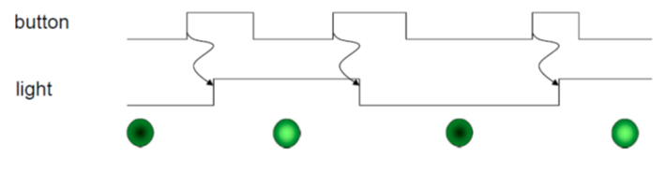
- Test whether the following code can have the correct results.
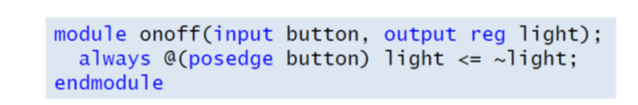
- Write the correct Verilog module and implement it in the board.
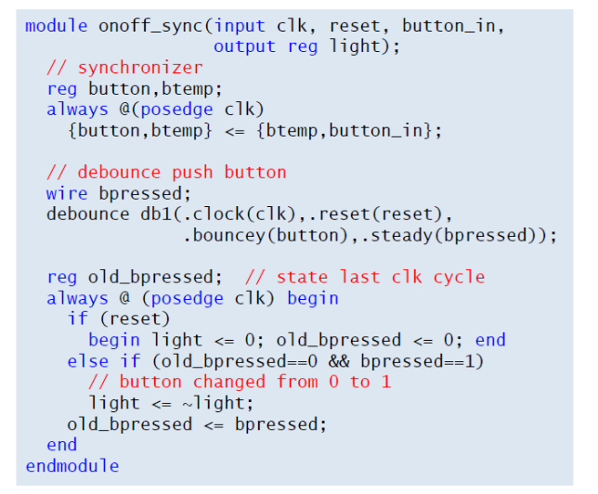
- There are three processing sub-circuits in the module. Try remove part of them and test whether the results are correct.

